Nepal College of Information Technology
Unit Test
Fall 2013
Program : BE ELX Time : 2 hrs
Semester : (III) FM : 60
Subject : Engineering Math-III PM : 30
- Candidates are requested to give their answer as far as practicable in their own words.
- The figure in the margin indicates the full marks
- Attempt ALL question

1. a) A Particle moves along the curve 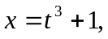 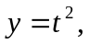 8
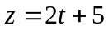 find the components of its velocity and acceleration at t=2 in the direction of 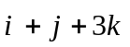
b) Find the directional derivative of 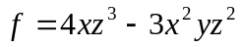 at (2,-1,2) along z-axis. 7
2. a) If 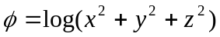 find div(grad) and curl (grad) 8

b) Calculate 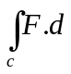 if 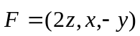 7
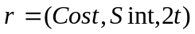 from (0,0,0) to (1,0,4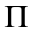)
3. a) Calculate 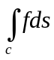 if 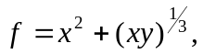 c is the hypocycloid, 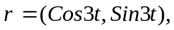 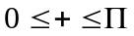 8
b) Show that the vector 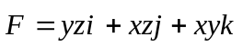 is Conservative and find such that 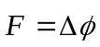 7
4. a) Show that the integral 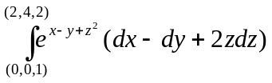 is exact and evaluate the integral 8
b) If Show that is Solenoidel 7

Nepal College of Information Technology
Unit Test
Fall 2013
Program : BE ELX Time : 2 hrs
Semester : Fall (III) FM : 60
Subject : Engineering Math-III PM : 30
- Candidates are requested to give their answer as far as practicable in their own words.
- The figure in the margin indicates the full marks
- Attempt ALL question

1. a) A Particle moves along the curve 8
find the components of its velocity and acceleration at t=2 in the direction of
b) Find the directional derivative of at (2,-1,2) along z-axis. 7
2. a) If find div(grad) and curl (grad) 8

b) Calculate if 7
from (0,0,0) to (1,0,4)
3. a) Calculate if c is the hypocycloid, 8
b) Show that the vector is Conservative and find such that 7
4. a) Show that the integral is exact and evaluate the integral 8
b) If Show that is Solenoidel 7

